# Preliminary Accessibility Audit of Bob’s Zeppelin screens

## Screen 1: Login Screen

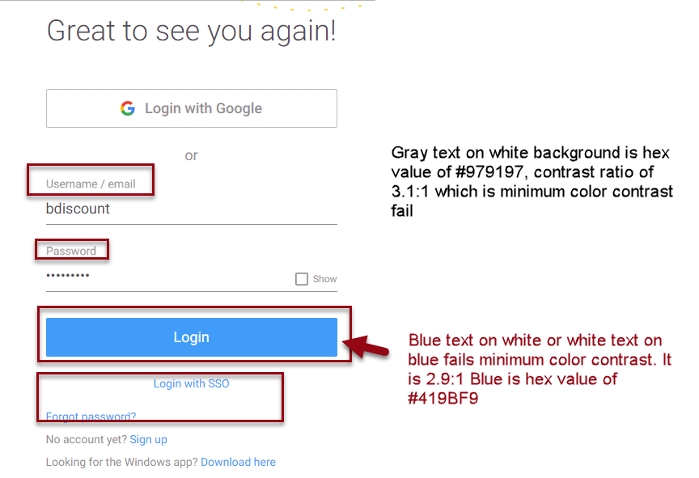

## Screen 2: Landing Screen

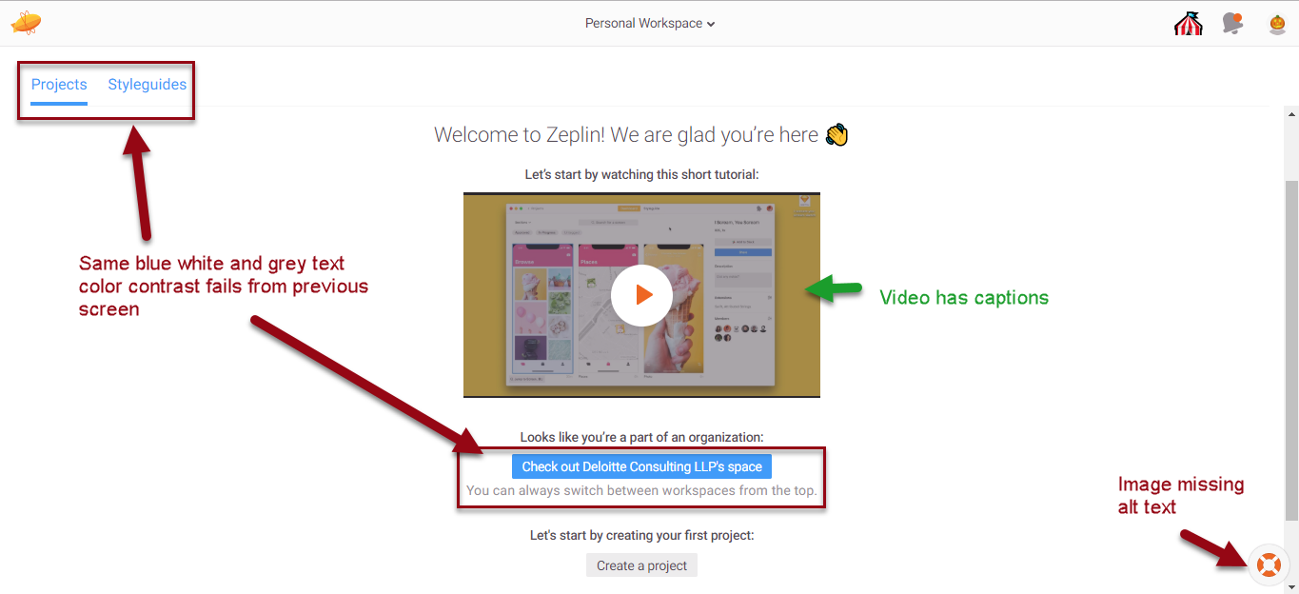

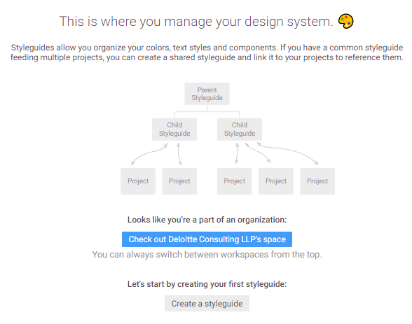

Then this if you select Create a Styleguide

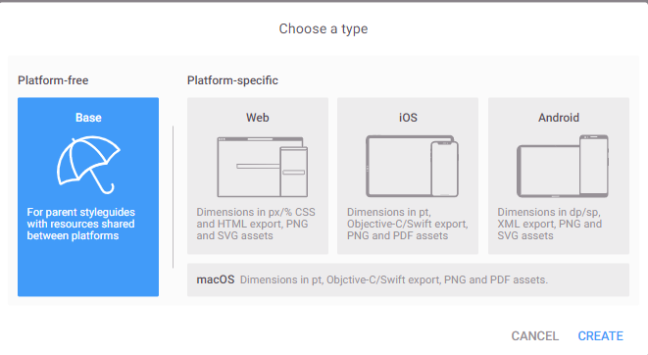

Then this under Base for Web

